Title:
Soft Materials Engineering in Flatland: 2D Colloid Crystals, and Polymer Lung Surfactants

Abstract:
This talk will discuss technology-driven and fundamental research that demonstrates how basic research in interfacial science can help solve problems with great societal impact. Specifically, two research projects will be discussed: one on the guided assembly of colloids at the air-water interface, and the other on the rational development of polymer lung surfactant therapeutics.

High-quality colloid crystals have potential utility in many technological applications. Therefore, precise and economical fabrication of 2D (and eventually 3D) colloid crystals presents essential opportunities for advancement of these technologies. We developed a new, vastly improved method of producing highly-ordered 2D colloid crystals with unprecedented efficiency and precision. This method works by transferring a monolayer of colloidal particles initially constructed at the air-water interface onto a substrate which contains micro-fabricated topological patterns via the so-called Langmuir-Blodgett (LB) technique. Through theoretical and experimental analyses, we established, for the first time, the importance of maintaining high environmental humidity during the LB process for producing defect-free (colloid crystal) LB monolayers. This finding also has implications for other research areas, for instance, for lipid membrane research where the LB method is a standard technique for sample preparation.

The so-called surfactant replacement therapy (SRT) (i.e., administration of animal-extracted lung surfactants into the lungs of patients such as premature infants), developed as a result of the lung surfactant research, has now become a well-established treatment of respiratory distress syndrome (RDS) in infants in the US and other developed countries. However, the high cost of this treatment is currently an obstacle to its more widespread use in many less developed countries. A cheaper lung surfactant (i.e., a surrogate surfactant of fully synthetic origin that can be mass produced cheaper, are suitable for non-invasive delivery, and have longer shelf-lives than currently available SRT therapeutics) would certainly help make the surfactant therapy a more affordable therapeutic option. Through studies of the air-water interfacial properties of a wide range of biocompatible/biodegradable polymers, we developed a detailed understanding of how certain polymers are able to produce extremely low air-water interfacial tensions under dynamic compression (similarly to the natural lung surfactant) and what molecular factors contribute to these behaviors. This investigation led to an identification of a promising class of candidate materials that have all desired properties for potential lung surfactant applications. Studies in animal models confirmed that polymer lung surfactants are safe and, in fact, more efficacious than current commercial therapeutics. Recently, we have started efforts to commercialize this technology.

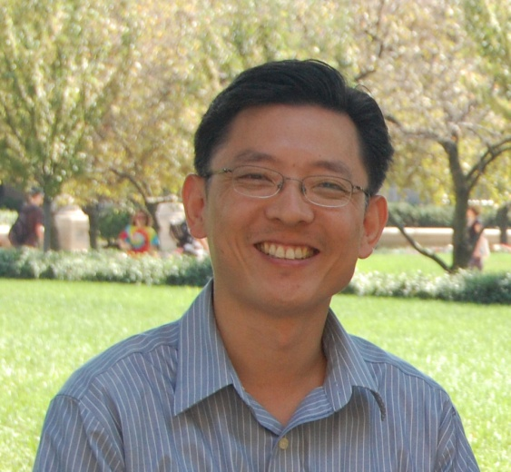
Biosketch:
Dr. Won earned a B.S. degree with top honors in Chemical Engineering from Seoul National University (1992). He received his Ph.D. degree in Chemical Engineering from the University of Minnesota (2000), and Postdoctoral training in Applied Physics at Harvard (2001 – 2003) and in Materials Science and Engineering at MIT (2000 – 2001). Dr. Won joined the Purdue faculty as an Assistant Professor of Chemical Engineering in 2003, and was promoted to Full Professor in 2014. Dr. Won’s current research focuses on developing and studying (1) radio-luminescent theranostic agents for cancer treatment and (2) synthetic pulmonary surfactants for treatment of respiratory failure. Dr. Won founded two startup companies to commercialize these technologies.

