Engineering with Air: Frontiers in Structural Metamaterials
Brad L. Boyce, Ph.D.
Distinguished Member of the Technical Staff, Sandia National Laboratories
CINT Scientist, Center for Integrated Nanotechnologies

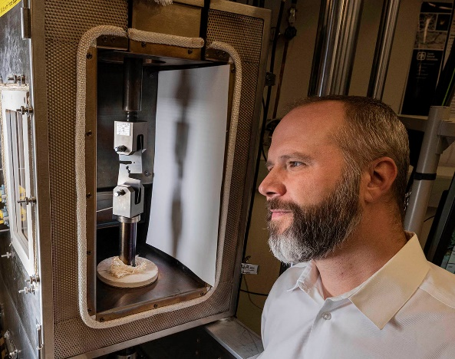

Abstract: Structural metamaterials, also known variously as lattice-, truss-, architected-, or programmable-materials, possess unique mechanical properties as a result of their designed topology, most notable high strength-to-weight and stiffness-to-weight ratios. In this presentation, we describe novel Sandia topologies for controlling the transfer and dissipation of energy. To optimize metamaterial architectures, we will also discuss efficient computational methods for nonlinear and multifunctional design. Finally, we illustrate the important role of manufacturing-induced defects, such as surface roughness and porosity, that are often ignored in design but can dominate product qualification. Machine learning methods, including deep neural networks and genetic algorithms, provide potential new pathways to overcome challenges in design and qualification.

Bio: Dr. Boyce is a Distinguished Member of the Technical Staff at Sandia National Laboratories. Dr. Boyce received the B.S. degree from Michigan Technological University in 1996 in Metallurgical Engineering and the M.S. and Ph.D. degrees in 1998 and 2001 from the University of California at Berkeley. Dr. Boyce joined the technical staff at Sandia in 2001 where his research interests lie in micromechanisms of deformation and failure. He has published over 140 peer reviewed articles and holds 6 U.S. patents on topics such as microsystems reliability, nanoindentation, fracture in structural alloys, weld metallurgy, and fatigue mechanisms. Dr. Boyce is a past recipient of the Hertz Foundation fellowship, the J. Keith Brimacombe Medal, and the Marcus A. Grossman Young Author award. He is also incoming vice president of TMS, The Minerals, Metals, and Materials society.
Sandia National Laboratories is a multimission laboratory managed and operated by National Technology and Engineering Solutions of Sandia, LLC., a wholly owned subsidiary of Honeywell International, Inc., for the U.S. Department of Energy’s National Nuclear Security Administration under contract DE-NA-0003525.

Related hyperlinks:
https://scholar.google.com/citations?user=53pzNQYAAAAJ&hl=en&oi=ao
https://www.lanl.gov/search-capabilities/profiles/brad-boyce.shtml

